*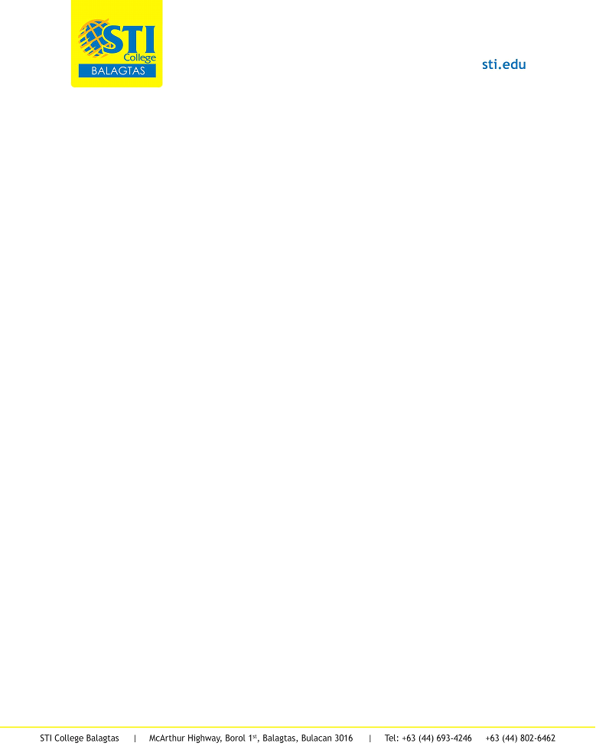*

STI COLLEGE BALAGTAS

Student Report